

Fundamentals of Programming

ME-15

Section B

1st Semester

Date of Submission: 11/10/2023

Haniyyah Abbas 481755

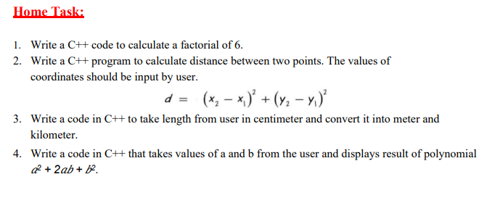

#include<iostream>;

#include<cmath> **// this is important to mention, otherwise the 'sqrt' and the 'pow' won’t be declared.**

**using namespace std**;

int main(){

float d, x1, x2, y2, y1;

cout<<"Enter x1 coordinate"<<endl;

cin>>x1; **//input variable x1**

cout<<"Enter x2 coordinate"<<endl;

cin>>x2;

cout<<"Enter y1 coordinate"<<endl;

cin>>y1;

cout<<"Enter y2 coordinate"<<endl;

cin>>y2;

d = sqrt(pow(x2-x1,2) + pow(y2-y1,2)); **//formula for distance**

cout<<"Distance between two points is:"<< d <<endl;

return 0; }

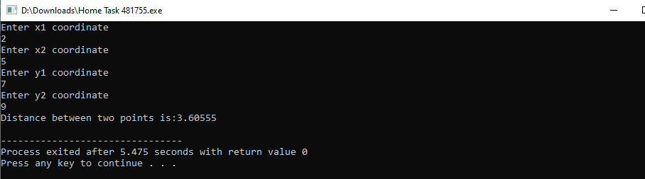

#include <iostream>;

using namespace std;

int main(){

float centimeters, meters, kilometers; **//used float so that the answer can be given in decimals**

cout<<"Enter length in centimeters:"<<endl;

cin>>centimeters;

meters=centimeters/100; **//conversion to meters**

cout<<"Length in meters:"<< meters << endl;

kilometers=centimeters/100000; **//conversion to kilometers**

cout<<"Length in kilometers:"<< kilometers << endl;

return 0;}

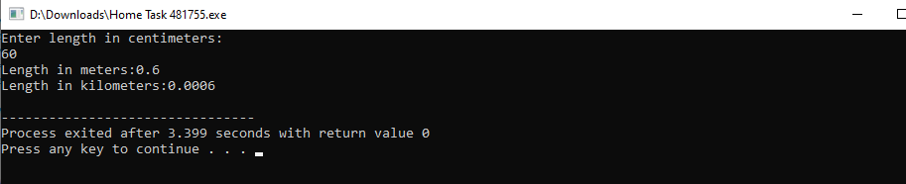

#include <iostream>;

#include<cmath>;

using namespace std;

int main(){

int a, b, c;

cout<<"Enter value a:"<<endl;

cin>>a;

cout<<"Enter value b:"<<endl;

cin>>b;

c = pow(a,2)+2*a*b+pow(b,2); **//formula for polynomial**

cout<<"Value of polynomial:"<< c << endl;

return 0;}

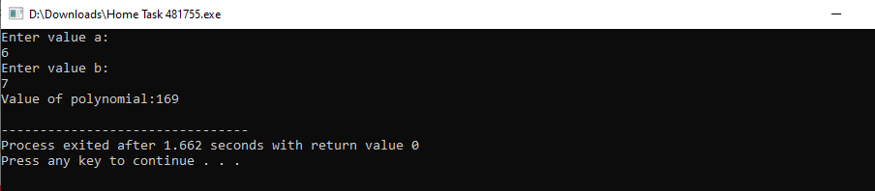

#include<iostream>;

using namespace std;

int main(){

int a = 6, n;

cout<<"Enter number:"<<endl;

cin>> a;

n = a*(a-1)*(a-2)*(a-3)*(a-4)*(a-5); **//formula for the factorial of 6**

cout<<"Value of factorial:"<< n << endl; **//nessecary to write second variable so that the answer is given**

return 0;}

